Wpisz niemieckie nazwy w odpowiednie miejsce.

|  |  |  |  |  |  |  |  |  |  |  |  |  |  |  |  |
| --- | --- | --- | --- | --- | --- | --- | --- | --- | --- | --- | --- | --- | --- | --- | --- |
|  |  |  |  |  | **K** |  |  |  |  |  |  |  |  |  |  |
|  |  |  |  |  | **O** |  |  |  |  |  |  |  |  |  |  |
|  |  |  |  |  | **M** |  |  |  |  |  |  |  |  |  |  |
|  |  |  |  |  | **M** |  |  |  |  |  |  |  |  |  |  |
|  |  |  |  |  | **O** |  |  |  |  |  |  |  |  |  |  |
|  |  |  |  |  | **D** |  |  |  |  |  |  |  |  |  |  |
|  |  |  |  |  | **E** |  |  |  |  |  |  |  |  |  |  |

 My …..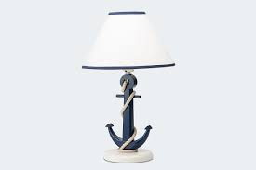I Ja ……………..