Krzyżówka dla uczniów kl IV

Martyna Loster kl IVb

|  |  |  |  |  |  |  |  |  |  |
| --- | --- | --- | --- | --- | --- | --- | --- | --- | --- |
|  | |  | |  |  |  |  |  |  |
|  |  | |  |  |  |  |  |  | | | | | |
|  |  | |  |  |  |  |  |  |  | | | | |
|  |  | |  |  |  |  |  |  | | | | | |
|  | | | | | |  |  |  |  |  | | | |
|  |  |  |  |  |  | | |
|  | | | | |  |  |  |  |  |  | | | |
|  | | | |  |  |  |  |  |  | | | | |
|  |  |  |  |  |  |  |  |  |  |  |
|  |  |  |  |  | | | | |
|  |  |  |  |
|  |  |  |  |

Ich liebe ……………………………… .

1. 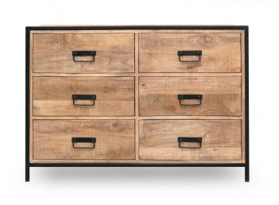 2.  3. 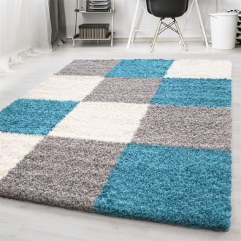

4. 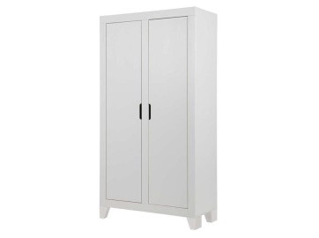 5. 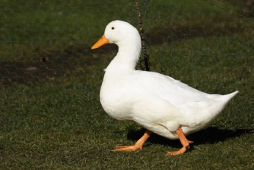 6. 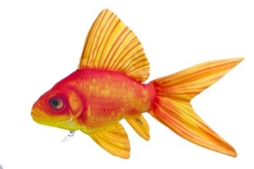

7. 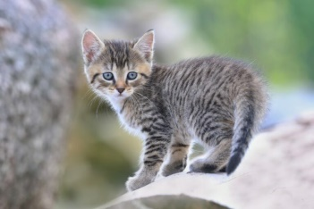 8. 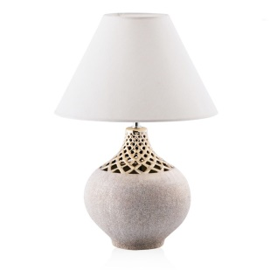 9. 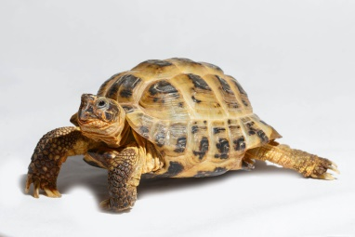

10.  11.  12. 