|  |  |  |  |  |  |  |  |  |  |  |
| --- | --- | --- | --- | --- | --- | --- | --- | --- | --- | --- |
|  |  |  |  |  |  | **1** |  |  |  |  |
|  |  | **2** |  |  |  |  |  |  |  |  |
| **3** |  |  |  |  |  |  |  |  |  |  |
|  | **4** |  |  |  |  |  |  |  |  |  |
|  |  |  |  |  | **5** |  |  |  |  |  |
|  |  |  | **6** |  |  |  |  |  |  |  |

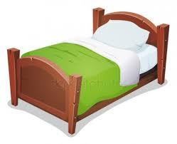1

2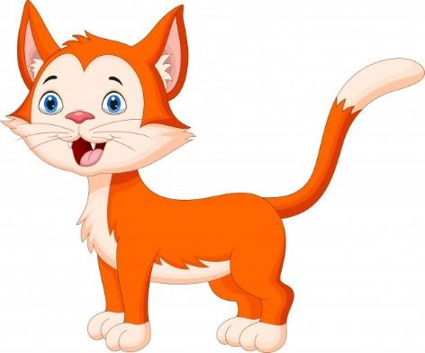

3

4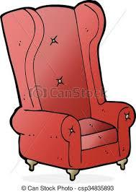

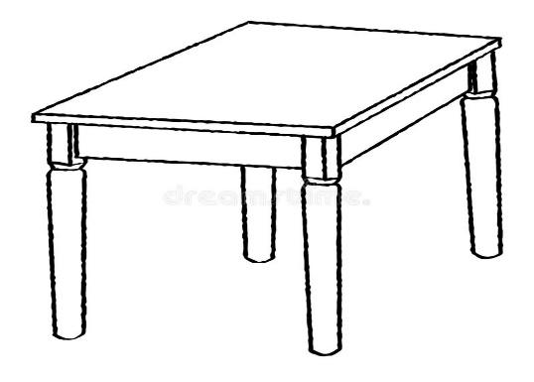5

6

Uzupełnij krzyżówkę odpowiednimi hasłami.